

INTERNATIONAL SPACE APPS CHALLENGE 2019

**GALAXY CRAFT**

THE BLACKHOLE TEAM

**Team members:**

* Diego Enrique Graciano García
* Martha María Navarro Castellanos
* Ana Luisa Gallegos Ayala
* Rivaldo Osmar Maldonado Jiménez

**Index**

1. **Abstract**
2. **Introduction**
   1. User histories.
3. **Functionoid**

3.1. functionality through diagrams.

3.2 Functionality from video or demonstrative sketches

3.3 Ease of use

1. **Technological Architecture**

4.1 Technology platforms

4.2 Development methodologies

**5. Aggregate value**

5.1 Portability

5.2 Connectivity

**6. Bibliography**

1. **Abstract**

Education in the early stages of life is a fundamental basis for the social and intellectual development of everyone, through this cognitive stimulation is sought by fueling curiosity.

This part is a key piece in the growth of science, because studies confirm that the age at which a profession is chosen is between 10 and 16 years. (2019, ALAR).

However, in Mexico and in other countries of the world there is no vocational guidance or information necessary for young people to develop a solid interest in science, due to the small interactive and mechanical way of introducing science into their lives.

The objective of this project is to inspire young people to immerse themselves in science, this, awakening their interest through a video game, which is based on a universe of their own creation, with which they will have the opportunity to acquire knowledge on it space, from how the universe is organized, to the chemical composition of planets, stars or entire galaxies.

This project seeks to inspire the youngest population, so that, in the future, there are more professionals involved in the scientific field, thus generating better opportunities for innovation and development.

**2. Introduction**

New research reveals that infants and young children learn by testing hypotheses, analyzing statistics, making causal inferences, observing what happens and conducting experiments. In other words, as explained in the journal Science Alison Gopnik, a researcher at the University of California at Berkeley (USA), children often use scientific reasoning in their games and interactions with other subjects. To verify this, Gopnik carried out a series of experiments with machines that played music. After asking the children to activate them, they observed that they first hypothesized how to operate the devices - which were activated by simultaneously activating two blocks - and then found out which one was more plausible. (2018, CONACYT).

"Everyday game is a form of experimentation with the world, of obtaining data and of extracting new conclusions," says Gopnik, who says that it is necessary to let them learn by themselves doing "trials" as scientists instead of telling them They have to know. Intuitive experimentation, adds the researcher, allows us from very early ages to discover the causes and effects behind what is happening around us better than any other method. Hence, he recommends changing the teaching method of preschoolers, which tends to underestimate their intellectual abilities. (2018, CONACYT).

One of the most effective modern ways of learning today are videogames, because they involve their user with history and curiosity.

Making the relationship between science and technology, Galaxy craft emerged, a video game based on the creation of a user's own universe, so that it interacts with each of the stages of formation of some celestial body.

2.1. User stories

2.1.1 Upon entering the game, the user will find an access screen, in which a registration will be requested that has the option to be made through a Facebook account or email which will be stored in a database, by what will be possible to save the progress of the player and allow his entrance and exit of the game.

2.1.2 Being the first time the user accedes, a story told about the origin of the universe will be shown.

2.1.3 After the video, the game screen will be displayed, in which, we will be able to observe the options and resources available to the player, which will begin by choosing the name of his galaxy, where a planet and a planet will be provided. Sun, which can be modified at your choice, through the rewards you get by playing the challenges of the game.

2.1.4 The user will have the option of incorporating life into their planet, through the implementation of microorganisms; Likewise, you will have the opportunity to modify the properties of these, to provide specific characteristics to their future inhabitants.

2.1.5 With each mission that the user successfully completes, a specific amount of rewards will be provided, which, in Galaxy Craft, are referred to as “atoms” that in the game have the function of coins.

2.1.6 Upon exiting the game and entering again, the player's last game will be automatically loaded.

**3. Functionality**

3.1 Functionality through diagrams

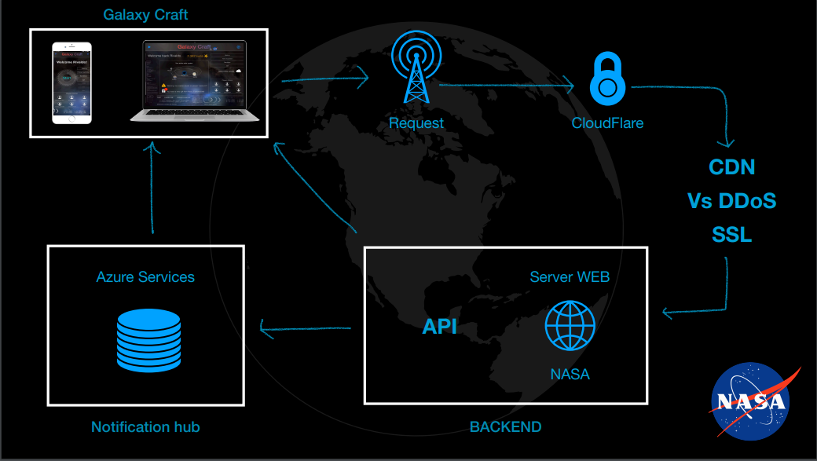

Figure 1 Galaxy Craft functionality diagram

3.2 Functionality from video or demonstrative sketches

* **Mock Up WebApp:** <https://www.figma.com/proto/ec84QtNqWaxe8EM62J2Jp6/Galaxy-Craft?node-id=1%3A2&viewport=186%2C165%2C0.335895299911499&scaling=scale-down>
* **Mock Up mobile:** <https://drive.google.com/file/d/1D6dlRpxG578PQRB9k2NIK9sEOUK6Wzw8/view?usp=sharing>
* **webApp Demo:** <https://tita-navarro.github.io/build-a-planet/src/index.html>
* **webApp Code:** [www.github.com/Tita-Navarro/build-a-planet](http://www.github.com/Tita-Navarro/build-a-planet)
* **Mobile App repo:** <https://github.com/Hackerciano/NasaSpaceApps.git>
* **Trailer:** <https://youtu.be/ZyLN6sGB3xE>

3.3 Ease of use

One of the main features sought when implementing a new virtual learning system is the simplicity of its use, since being something new, the user must have the necessary tools to understand and use the game in a practical and effective way from the first interaction with this.

Because of this, our platform combines simplicity with innovation.

Its perfectly structured design gives the user the opportunity to Immediately understand its operation, likewise, thanks to its programming, learning becomes simple and interesting.

In addition, it allows us to consult designs based on photographs and real data provided by NASA, which offers a totally realistic user experience.

**4. Technological architecture.**

4.1 Technological platforms to use.

**• Swift:** to develop the mobile game.

**• Sketch:** To design the game flow

**• Java Script:** To create the webApp and to use the API`s from NASA.

**• Azure:** Is used for send notifications

**5. Added Values.**

5.1 Portability

Our platform is designed to make portability one of its main advantages, since being a web application, it allows the user to connect through any device (Smartphones, Tablet or PC) and thus play in real time, updating its progress constantly.

5.2 Connectivity

A server provided by NASA will be used as a base, in which the data of each user will be registered.

In turn, these will be saved by the Azure test service for the implementation of notifications.

Upon entering the game, the webApp will generate a request, which will be answered immediately by the server, returning to it an API with Json format.

In the case of notifications, either by the interaction with the game or by the notice of an update, this will be generated by the notification hub of the Azure service, which will send the data directly to the webApp.

As part of the communication with Azure, the existing Azure APIs will be used to connect databases used by NASA.

1. **Bibliography**

* Yavuzer, G., Senel, A., Atay, M.B., & Stam, H.J. (2008). «PlayStation EyeToy Games» improve upper extremity-related motor functioning in subacute stroke: A randomized controlled clinical trial. European Journal of Physical and Rehabilitation Medicine
* Swing, E. L., Gentile, D. A., Anderson, C. A., & Walsh, D. A. (2010). Television and video game exposure and the development of attention problems. Pediatrics, 126(2), 214-221
* Greitemeyer, T. and Osswald, S. (2009). Prosocial video games reduce aggressive cognitions. J
* Lomeli,D (2019) Ciencia y tecnología en la niñez, CONACYT, mexico.